Quick Guide:

How to Interpret Validation

Error Information in a

NIST HL7 V2 Test Tool

Version 1.0

Date: August 19, 2014

**Developed by the National Institute of Standards and Technology (NIST)**

**Quick Guide**

**How to Interpret Validation Error Information in a NIST HL7 V2 Test Tool**

When a NIST HL7 V2 Test Tool validates a test message, the test tool produces error notifications to indicate where the message is non-conformant to the conformance profile as defined by the particular implementation/messaging guide. **Figure 1** illustrates the validation process and describes the features available within the NIST Test Tools to assist the user with interpretation and correction of errors in a test message.

Figure 1. Overview of Validation Process and Interpretation of Errors

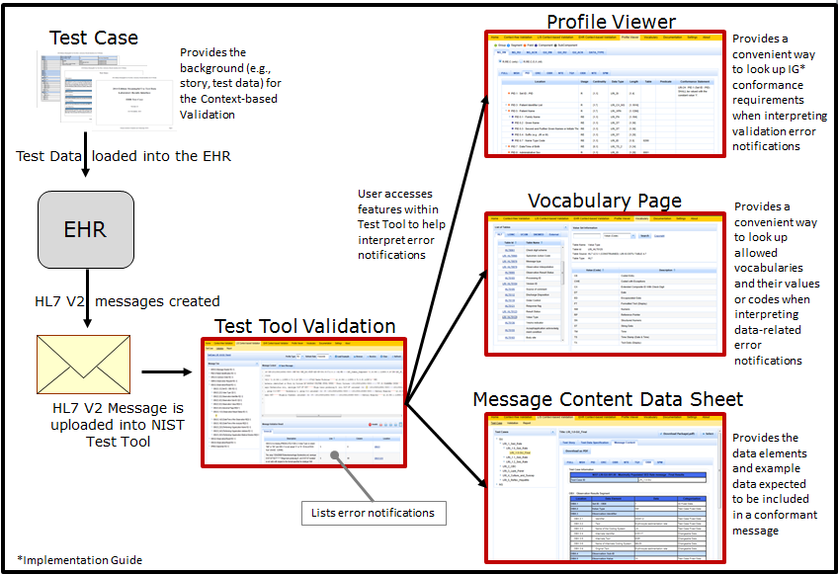

The error notifications are displayed immediately in the **Message Validation Result** section of the Validation window in the test tool. **Figure 2** shows the Validation window in which an example invalid Lab Result Interface (LRI) message displays in the Message Content section, and the associated errors display in the Message Validation Result section.

Figure 2. Example Invalid LRI Message and Message Validation Result

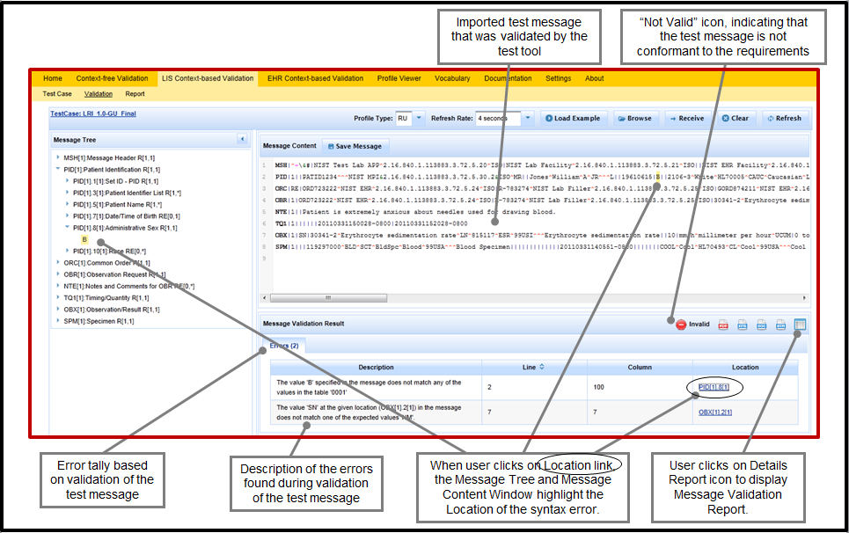

**Figure 3** shows details of the two error notifications from the example validation illustrated in **Figure 2**.

Figure 3. Display of Error Notifications in the Message Validation Result

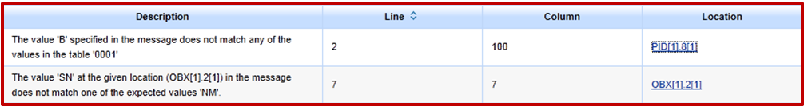

* The first error notification tells the user that the data value “B” at Location PID[1].8[1] in the message (i.e., the first instance of the eighth data element in the first PID segment in the message), and on Line 2/Column 100 of the Message Content window, is an error because “B” is not included in table ‘0001’, which is the allowable vocabulary for the data element
* The second error notification tells the user that the data value “SN” at Location OBX[1].2[1] in the message (i.e., the first instance of the second data element in the first OBX segment in the message), and on Line 7/Column 7 of the Message Content window, is supposed to be “NM”

The Location format for the information provided in an error notification is “SSS[n1].N1[n2].N2.N3”. An example would be “OBX[6].5[2].1”, which indicates that the Location of the error is in the first component of the second instance of the fifth data element in the sixth OBX segment in the message.

**Table 1** shows examples of data elements, components, and sub-components from a PID segment; and **Table 2** illustrates how the Location format would be applied if the error occurred in the first sub-component of the fourth component of the second instance of the third data element of the PID segment in a message – which would appear as “PID[1].3[2].4.1”. (The error notification Location format always includes data in the [ ] even when there is only one instance of the segment in the message or only one instance of the data element in the segment.)

Table 1. Illustration of PID Data Elements with Components and Sub-components

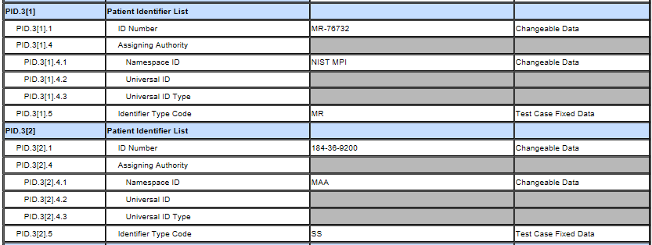

Table 2. Applying the Location Format for PID[1].3[2].4.1

| **Format** | **Format Description** | **Example** | **Example Description** |
| --- | --- | --- | --- |
| SSS | The Segment ID | PID | The PID Segment |
| [n1] | The instance of the segment in the message | [1] | The 1st instance of the PID segment in the message |
| .N1 | The ID for the data element in the segment | .3 | The 3rd data element in the PID segment |
| [n2] | The instance of the data element in the segment | [2] | The 2nd instance of the 3rd data element in the PID segment |
| .N2 | The component of the data element in the segment | .4 | The 4th component of the 3rd data element in the PID segment |
| .N3 | The sub-component of the data element in the segment | .1 | The 1st sub-component of the 3rd data element in the PID segment |